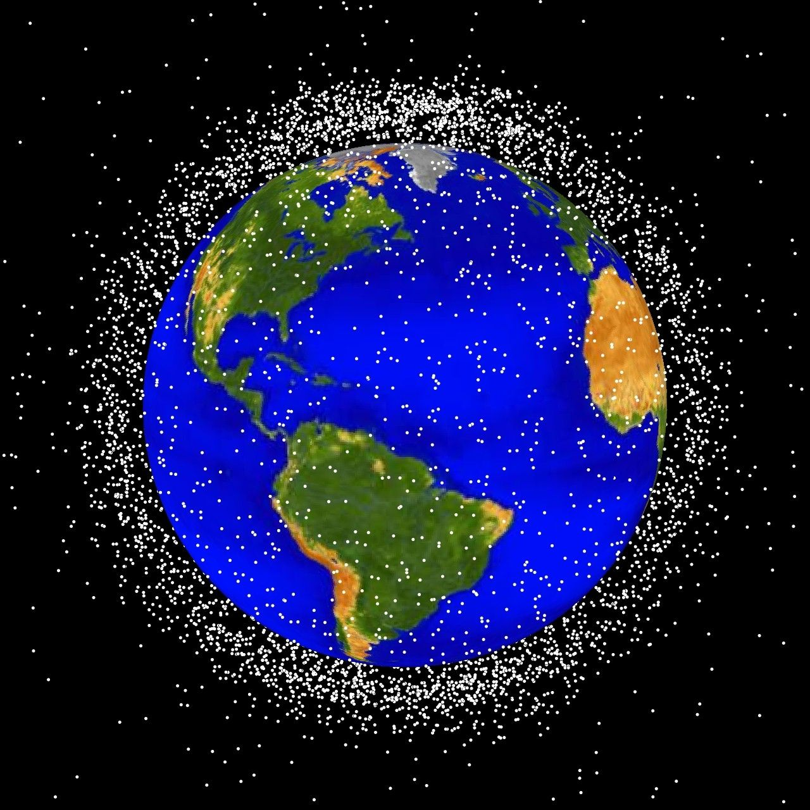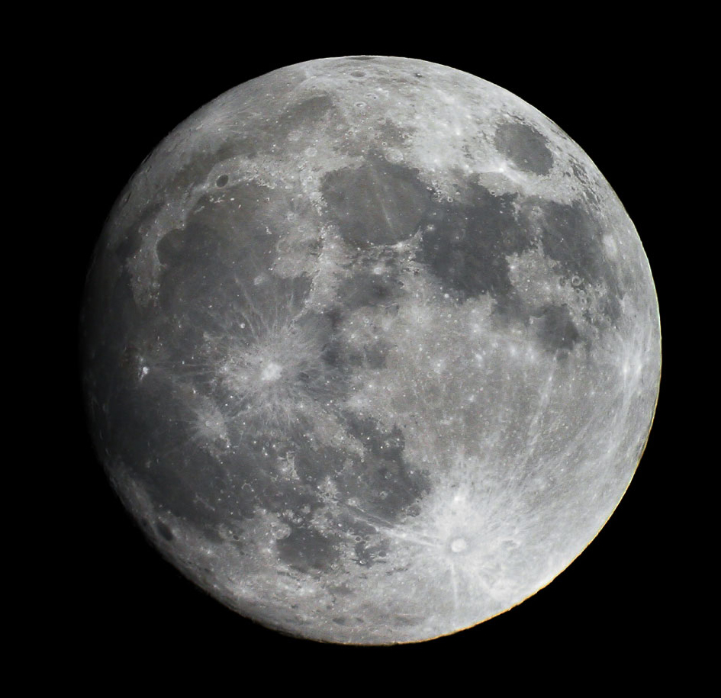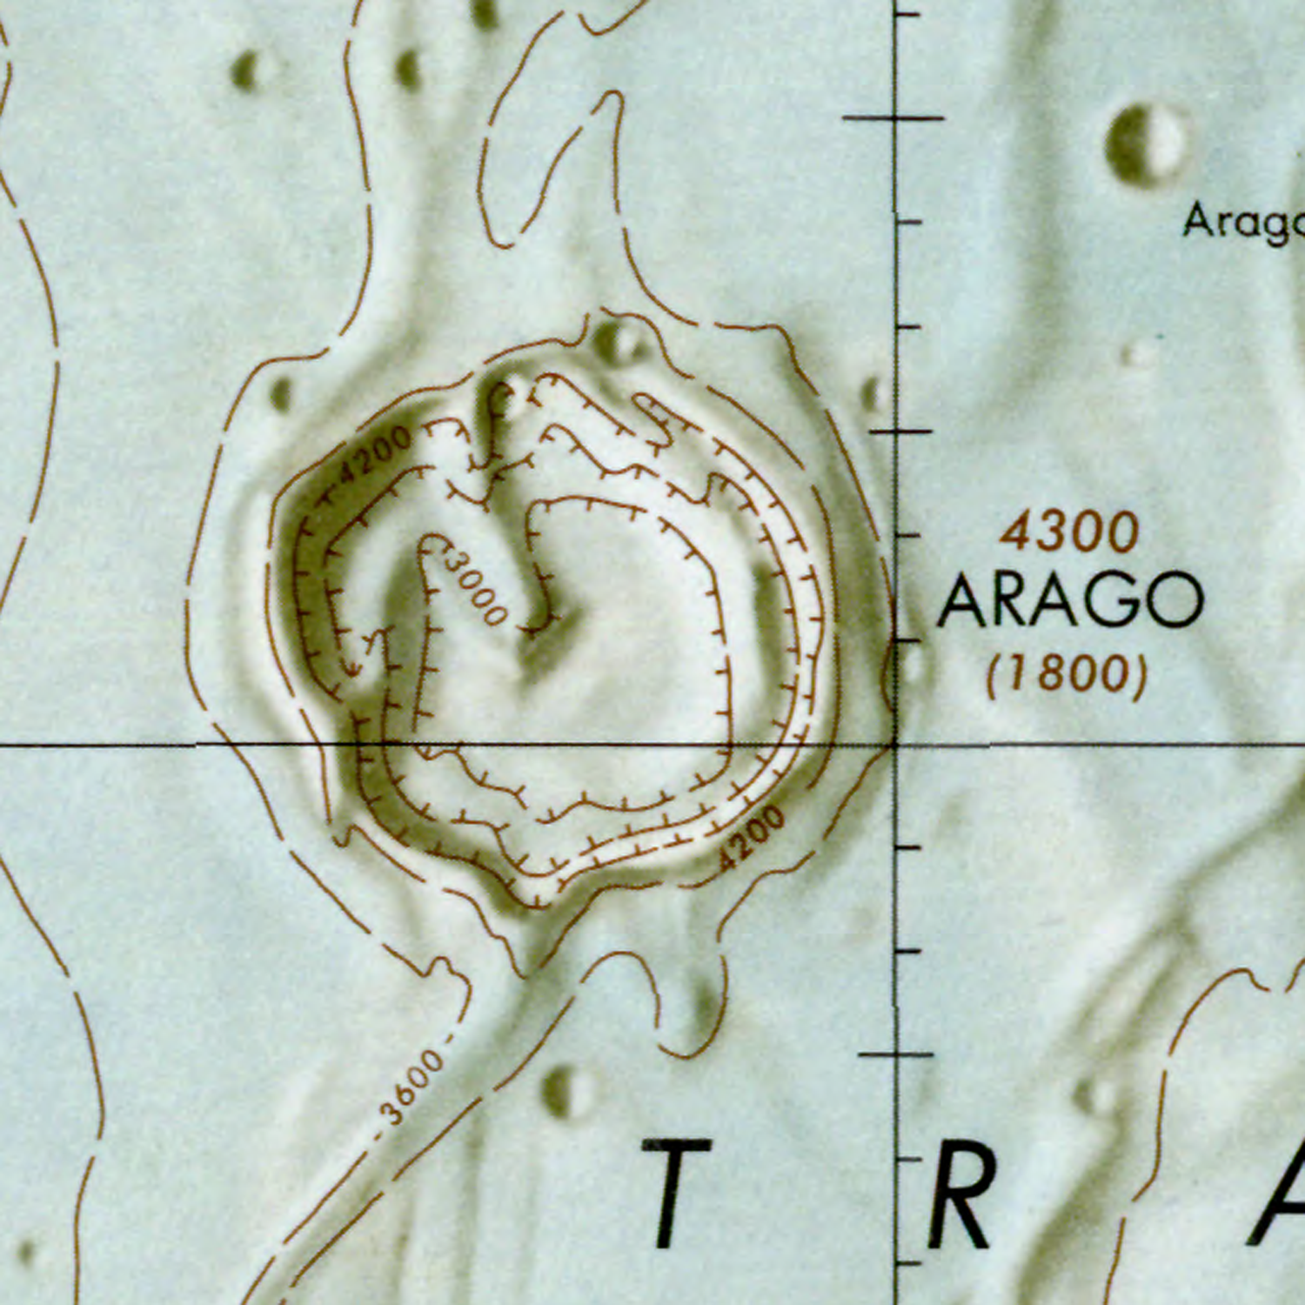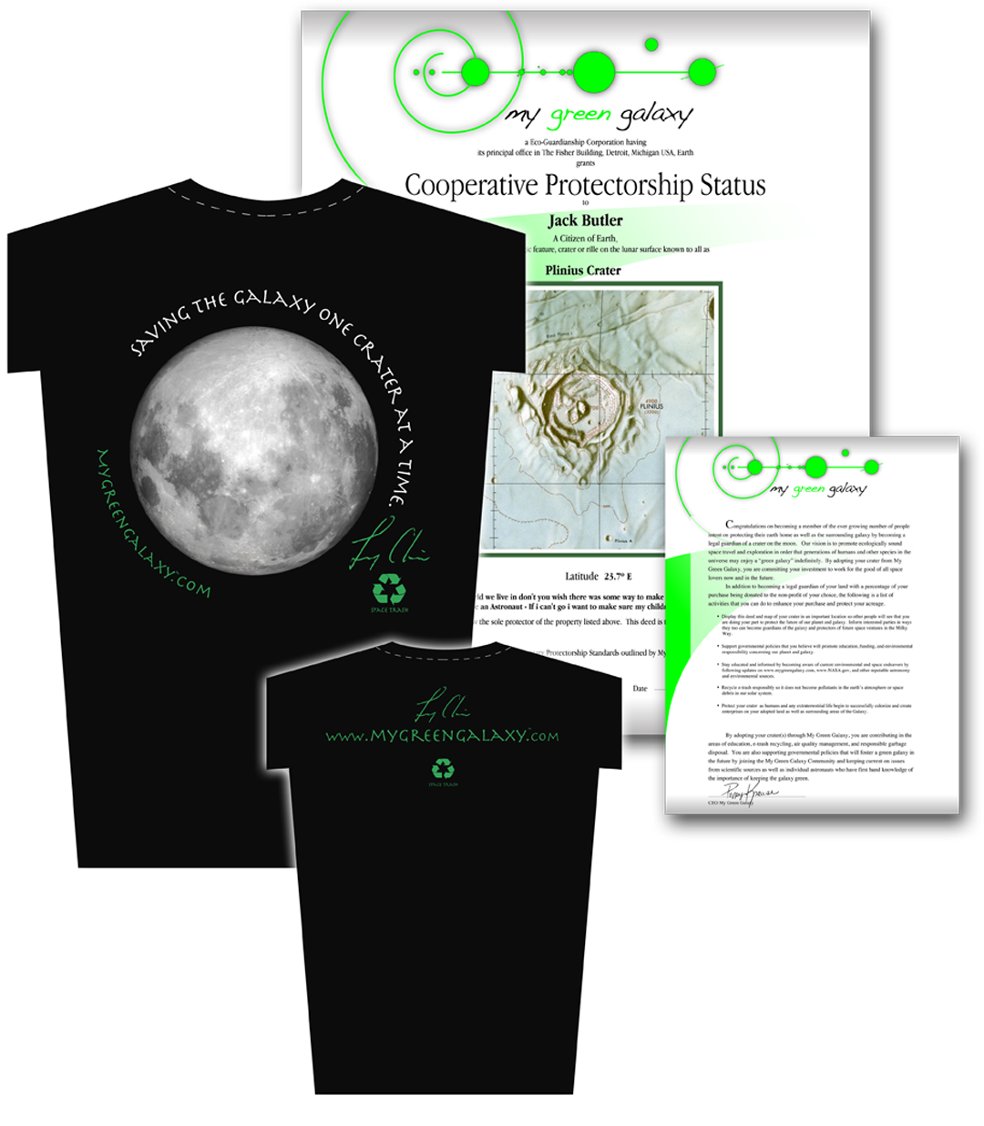

## Adopt a Crater

## Reduce Space Trash

By adopting a crater on the moon, you can become a part of educating the public about the problems created by space trash.

This initiative puts people in charge of specific bits of space ‚ assigns them protectorship of their bit of space and establishes many watchful eyes across the universe making sure that everyone is playing by the rules of good neighborliness and galactic consciousness.

A portion of the profits are donated to non-profits agencies that support this mission.

Summary

* Become aware of the problems caused by space trash by Adopting a Crater
* Display your crater to get other people involved and spread the word
* A portion of the profits will go toward non-profit agencies that support this cause
* Original, never before seen photos from space by Astronaut Leroy Chiao are also available on MyGreenGalaxy.com

Fisher Building

3011 W. Grand Blvd.  
Detroit, Michigan, 48202

Website: mygreengalaxy.com

Email: mygreengalaxy@me.com

Clean up Space Trash

“Adopt a Crater”

**Apollo 11 Landing**

**Site – Section 1**

Dr. Leroy Chaio’s unique view of our galaxy has inspired him to spread the word to people all over the world about the environmental impacts of space exploration. This mission has inspired him to co-found My Green Galaxy, further prompting him to post monthly blog posts to help combat through awareness the environmental impacts of space exploration.

Dr. Chaio gives readers an insight to space travel through his own missions in space by supporting educational agencies and sharing his own personal photos from space that can be purchased at MyGreenGalaxy.com to support the cause.

Space, the last frontier. littered with trash? That's right. Space is full of garbage. Scientists call it space trash, or space debris. Space trash is anything made by humans that's still orbiting in space, even if it’s not being used. This includes old satellites, parts of spacecrafts, and material left behind by astronauts.

Most space trash is tiny, but more than 10,000 pieces are wider than four inches, and the oldest piece of debris out there was a satellite launched 50 years ago.

How can a little speck of debris cause so many problems? It can damage working spacecrafts and satellites since trash travels at 22,000 miles per hour. When it hits another object, it’s more like a small explosion then a tiny fragment of metal bouncing off an object.

To prevent accidents, a special NASA agency tracks space trash. It also works to reduce the amount of garbage in space since Naas wants to make sure space doesn't become a giant landfill!

# Astronaut Leroy Chiao

### What’s the problem with Space Trash?